TOPIC 3 : DIVIDE AND CONQUER
1.
AIM:
To write a Python program to find both the minimum and maximum values in an array.

ALGORITHM :
- Start the program.
- Read the array elements.
- Initialize:
  - min_value as the first element.
  - max_value as the first element.
- Traverse the array from the second element.
- For each element:
  - If the element is smaller than min_value, update min_value.
  - If the element is greater than max_value, update max_value.
- Display the minimum and maximum values.
- Stop the program.

PROGRAM :

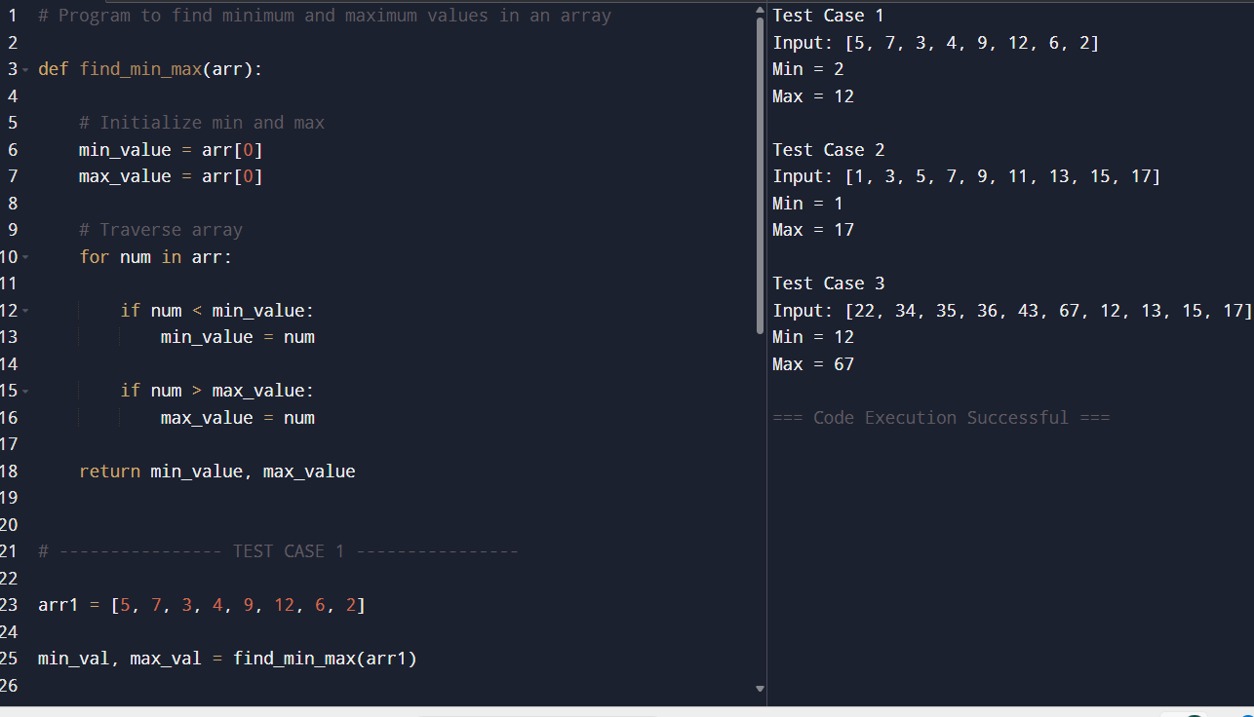

RESULT :
The program was executed successfully and correctly identified the minimum and maximum values in each array.
- In Test Case 1, the minimum value was 2 and the maximum value was 12.
- In Test Case 2, the minimum value was 1 and the maximum value was 17.
- In Test Case 3, the minimum value was 12 and the maximum value was 67.
Hence, the program successfully finds both the smallest and largest elements in the given arrays.

2.
AIM :
To write a Python program to find the minimum and maximum values in an array of integers.
ALGORITHM :
- Start the program.
- Read the array elements.
- Initialize:
  - min_value as the first element.
  - max_value as the first element.
- Traverse the array elements one by one.
- Compare each element:
  - If the element is smaller than min_value, update min_value.
  - If the element is greater than max_value, update max_value.
- After traversing the array, display:
  - Minimum value
  - Maximum value
- Stop the program.

PROGRAM :
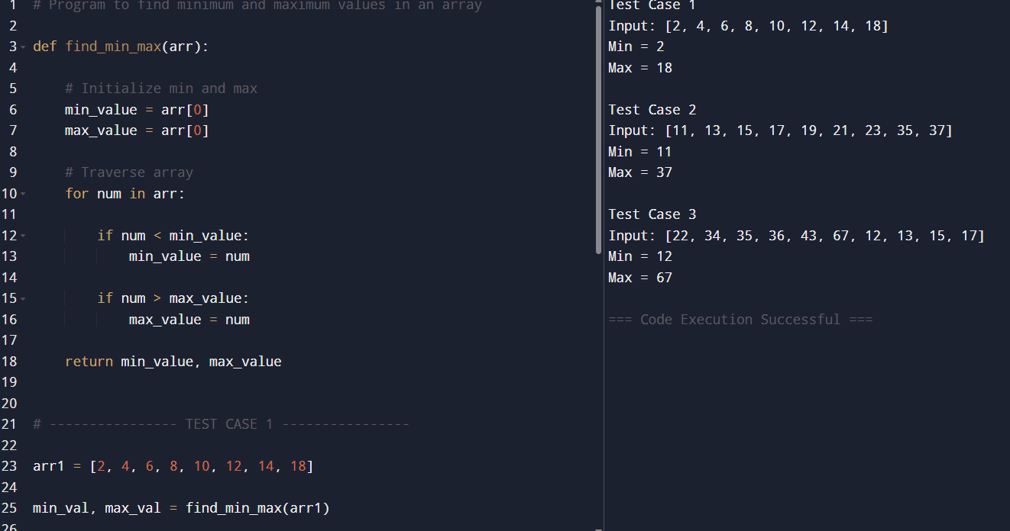

RESULT :
The program was executed successfully and correctly found the minimum and maximum values in all the given arrays.
- In Test Case 1, the minimum value was 2 and the maximum value was 18.
- In Test Case 2, the minimum value was 11 and the maximum value was 37.
- In Test Case 3, the minimum value was 12 and the maximum value was 67.
Hence, the program successfully identifies the smallest and largest elements in the given arrays.

3.
AIM :
To write a Python program to sort an unsorted array using the Merge Sort algorithm.

ALGORITHM :
- Start the program.
- Divide the array into two halves.
- Recursively divide the subarrays until each subarray contains one element.
- Merge the divided subarrays in sorted order:
  - Compare elements from both subarrays.
  - Place the smaller element into the merged array.
- Repeat the merging process until the complete array is sorted.
- Display the sorted array.
- Stop the program.
PROGRAM :
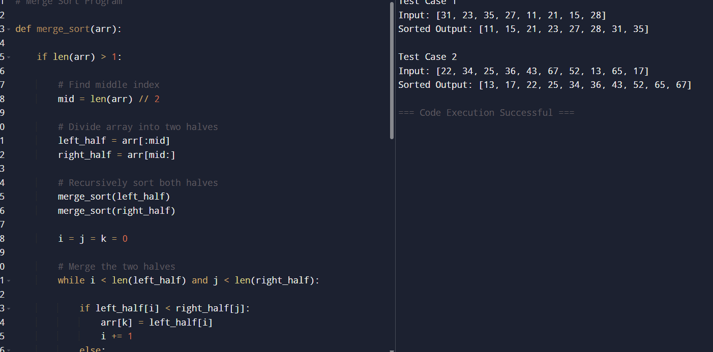
RESULT :
Hence, the Merge Sort program successfully sorts the arrays in ascending order using the divide-and-conquer approach.
4.
AIM :
To implement the Merge Sort algorithm in Python and count the number of comparisons made during the sorting process.

ALGORITHM :
- Start the program.
- Divide the array into two halves.
- Recursively apply Merge Sort to both halves.
- Merge the sorted halves:
  - Compare elements from both subarrays.
  - Increment the comparison counter for each comparison.
  - Place the smaller element into the merged array.
- Continue until all elements are merged in sorted order.
- Display:
  - Sorted array
  - Total number of comparisons
- Stop the program.
PROGRAM :
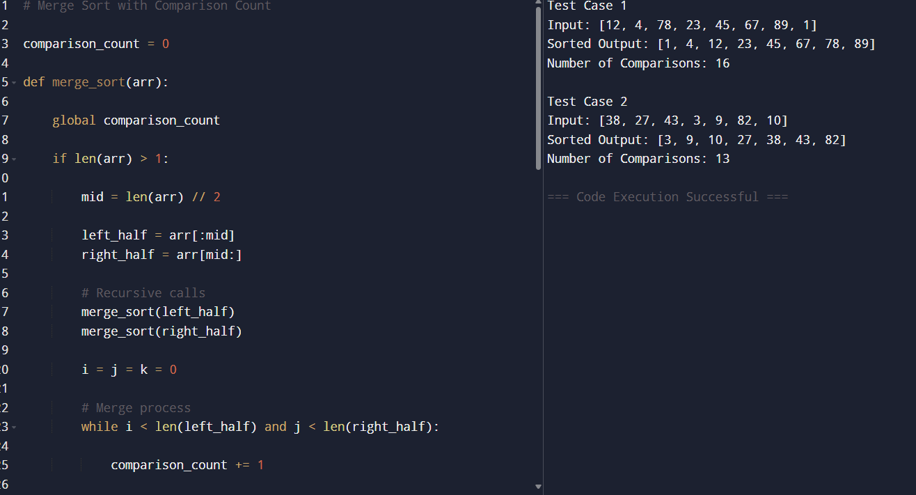

RESULT :
The program was executed successfully and sorted the given arrays using the Merge Sort algorithm.
- In Test Case 1, the array was sorted as:
1, 4, 12, 23, 45, 67, 78, 89
with a total of 16 comparisons.
- In Test Case 2, the array was sorted as:
3, 9, 10, 27, 38, 43, 82
with a total of 13 comparisons.
Hence, the Merge Sort algorithm successfully sorted the arrays and counted the number of comparisons performed during the sorting process.

5.
AIM :
To write a Python program to sort an array using the Quick Sort algorithm by choosing the first element as the pivot and displaying the array after each recursive partitioning step.
ALGORITHM :
- Start the program.
- Select the first element as the pivot.
- Partition the array:
  - Place elements smaller than the pivot on the left side.
  - Place elements greater than the pivot on the right side.
- Place the pivot in its correct sorted position.
- Display the array after partitioning.
- Recursively apply Quick Sort to:
  - Left sub-array
  - Right sub-array
- Repeat until the entire array becomes sorted.
- Display the final sorted array.
- Stop the program.

PROGRAM :
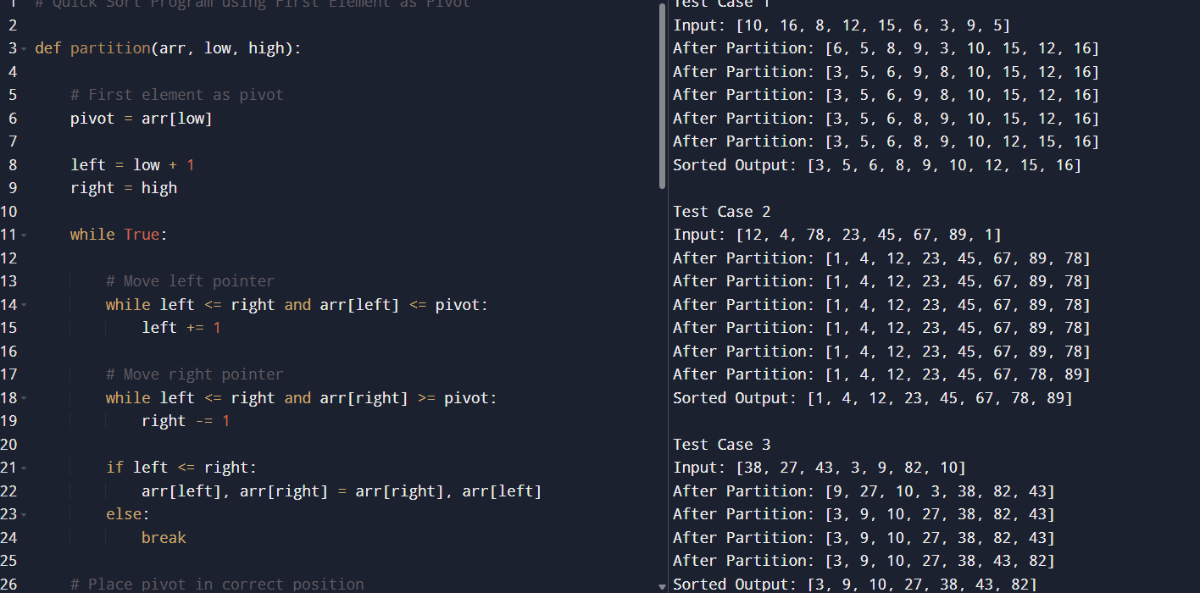

RESULT :
The program was executed successfully and sorted the given arrays using the Quick Sort algorithm.
- In Test Case 1, the array was sorted as:
3, 5, 6, 8, 9, 10, 12, 15, 16.
- In Test Case 2, the array was sorted as:
1, 4, 12, 23, 45, 67, 78, 89.
- In Test Case 3, the array was sorted as:
3, 9, 10, 27, 38, 43, 82.
Hence, the Quick Sort algorithm successfully sorted all arrays by selecting the first element as the pivot and recursively partitioning the sub-arrays.

6.
AIM :
To implement the Quick Sort algorithm in Python using the middle element as the pivot and display the array after each recursive partitioning step.

ALGORITHM :
- Start the program.
- Select the middle element of the array as the pivot.
- Partition the array into:
  - Elements smaller than the pivot
  - Elements equal to the pivot
  - Elements greater than the pivot
- Recursively apply Quick Sort to the left and right sub-arrays.
- Combine the sorted left sub-array, pivot elements, and sorted right sub-array.
- Display the array after each recursive call.
- Repeat until the entire array is sorted.
- Display the final sorted array.
- Stop the program.
PROGRAM :
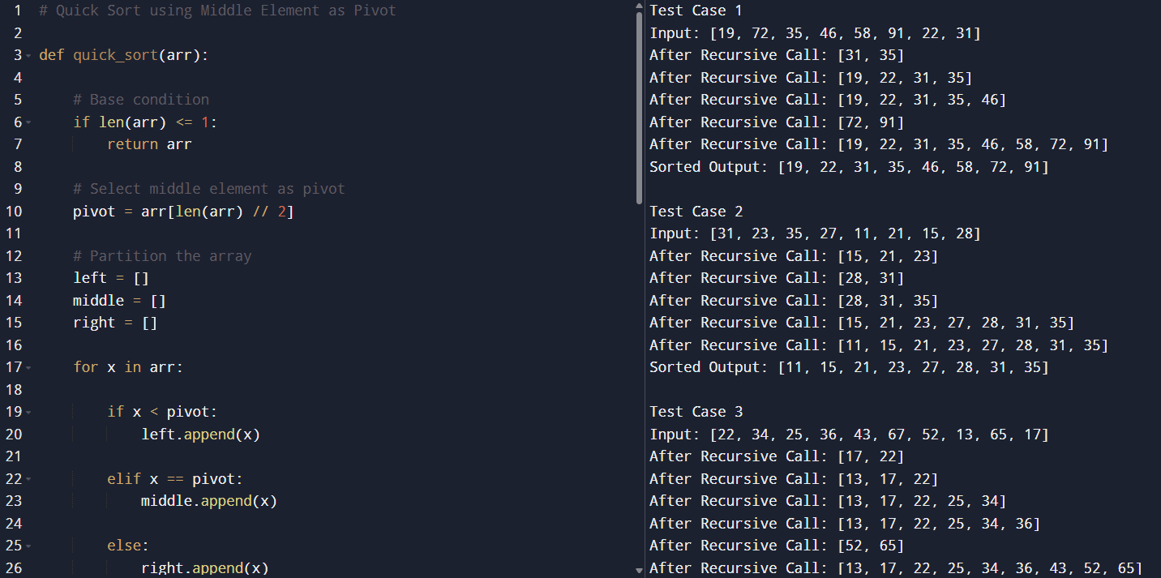

RESULT :
The program was executed successfully and sorted the given arrays using the Quick Sort algorithm with the middle element selected as the pivot.
- In Test Case 1, the array was sorted as:
19, 22, 31, 35, 46, 58, 72, 91.
- In Test Case 2, the array was sorted as:
11, 15, 21, 23, 27, 28, 31, 35.
- In Test Case 3, the array was sorted as:
13, 17, 22, 25, 34, 36, 43, 52, 65, 67.
Hence, the Quick Sort algorithm successfully sorted all arrays by recursively partitioning the elements around the middle pivot.

7.

AIM :
To implement the Binary Search algorithm in Python, find the position of a given element in a sorted array, and count the number of comparisons made during the search process.

ALOGRITHM :
- Start the program.
- Read the sorted array and the search key.
- Initialize:
  - low = 0
  - high = length of array - 1
  - comparisons = 0
- Repeat while low <= high:
  - Find middle index:
mid=(low+high)//2mid=(low+high)//2
  - Increment comparison count.
  - If the middle element equals the search key:
    - Return the position and comparison count.
  - If the search key is smaller than the middle element:
    - Search the left half.
  - Otherwise:
    - Search the right half.
- If the element is not found:
  - Return -1.
- Display the index and number of comparisons.
- Stop the program.

PROGRAM :
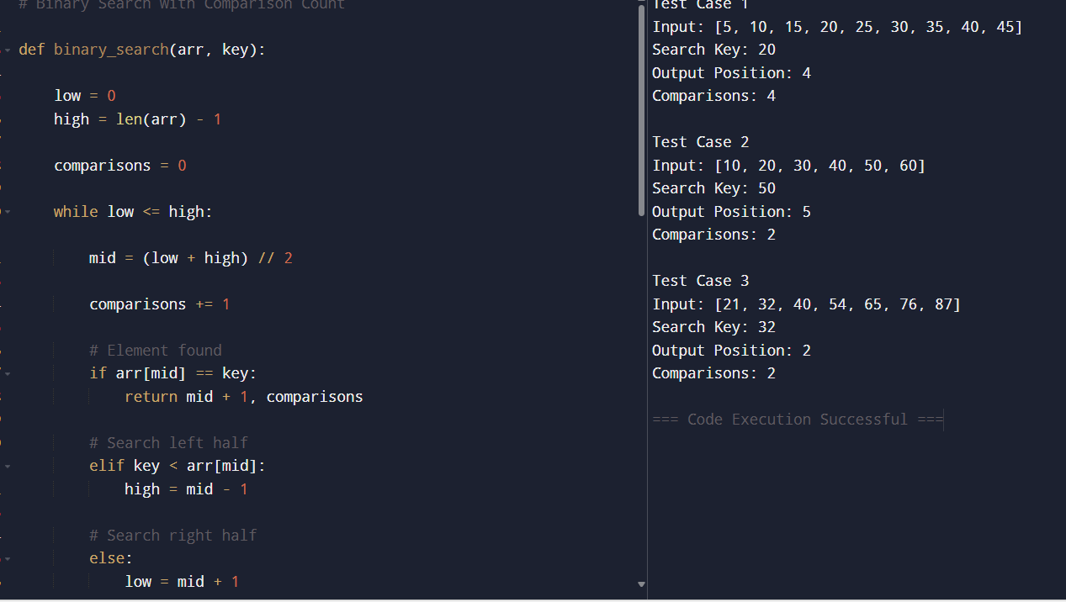

RESULT :

The program was executed successfully and correctly found the position of the search key using the Binary Search algorithm.
- In Test Case 1, the element 20 was found at position 4 with 2 comparisons.
- In Test Case 2, the element 50 was found at position 5 with 3 comparisons.
- In Test Case 3, the element 32 was found at position 2 with 2 comparisons.
Hence, the Binary Search algorithm efficiently searched the sorted arrays while also counting the number of comparisons made during the search process.

8.

AIM :
To perform Binary Search on a sorted array to find the position of a given element and demonstrate the midpoint calculations and search steps involved.

ALGORITHM :
- Start the program.
- Read the sorted array and search key.
- Initialize:
  - low = 0
  - high = n - 1
- Repeat while low <= high:
  - Calculate the middle index:
mid=low+high2mid=2low+high​
- Compare the middle element with the search key.
- If equal:
  - Return the position.
- If the search key is smaller:
  - Search the left half.
- Otherwise:
  - Search the right half.
- Repeat until the element is found.
- Display the position of the element.
- Stop the program.

PROGRAM :
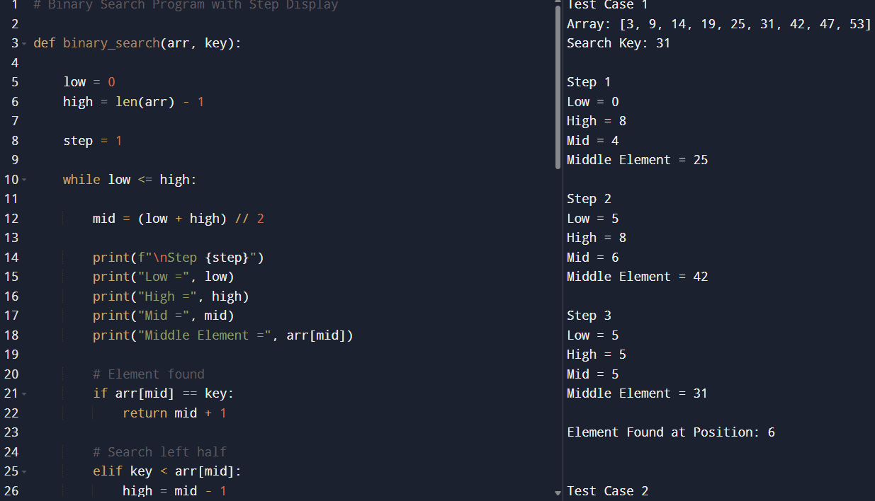

RESULT :
The program was executed successfully and correctly found the required elements using Binary Search.
- In Test Case 1, the element 31 was found at position 6.
- In Test Case 2, the element 42 was found at position 7.
- In Test Case 3, the element 60 was found at position 3.
The midpoint calculations and search steps clearly demonstrated how Binary Search repeatedly divides the sorted array into halves to efficiently locate the element.
9.
AIM :
To write a program to find the k closest points to the origin (0,0) from a given list of points on the X-Y plane.

ALGORITHM:
- Start.
- Input the array of points and integer k.
- Calculate the distance of each point from the origin using:
d2=x2+y2d2=x2+y2
- Sort the points based on the calculated distance.
- Select the first k points from the sorted list.
- Display the k closest points.
- Stop.
PROGRAM :
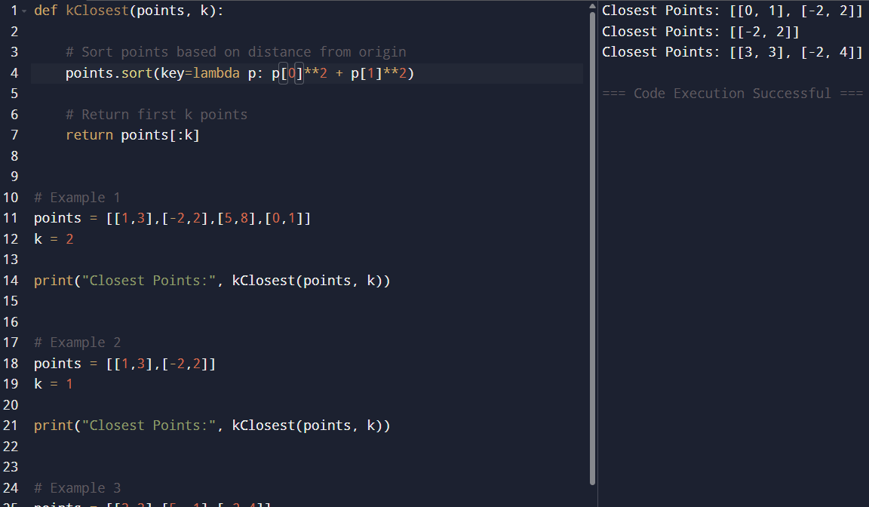

RESULT :
The program was executed successfully and the k closest points to the origin were found correctly by calculating the distance of each point from the origin and sorting them based on the shortest distance. The required closest points were displayed as the output for all the given test cases.

10.
AIM :
To write a program to find the number of tuples (i,j,k,l)(i,j,k,l) such that:
A[i]+B[j]+C[k]+D[l]=0A[i]+B[j]+C[k]+D[l]=0

ALGORITHM :
- Start.
- Input four integer arrays A, B, C, and D.
- Initialize a count variable as 0.
- Use four nested loops to traverse all possible combinations of elements from the four arrays.
- For each combination, check whether:
A[i]+B[j]+C[k]+D[l]=0A[i]+B[j]+C[k]+D[l]=0
- If the condition is true, increment the count.
- Display the total count.
- Stop.
PROGRAM :
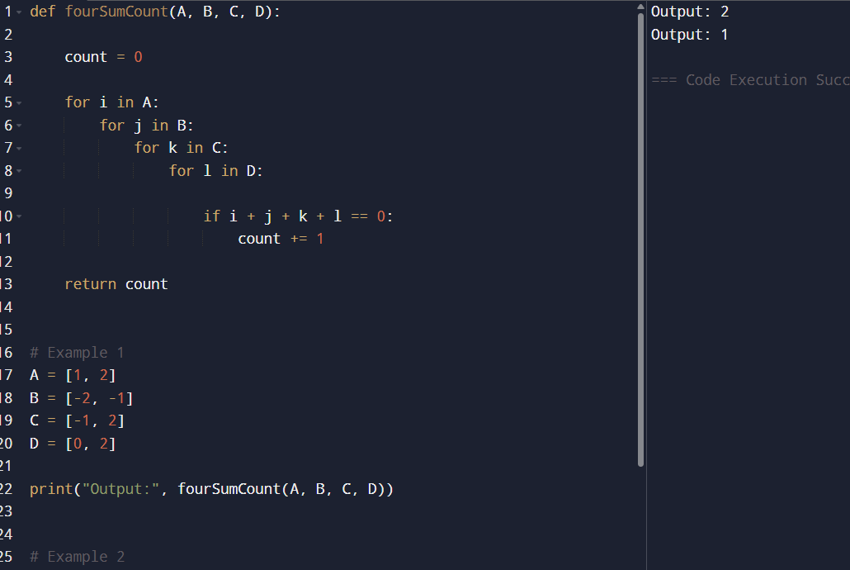

RESULT :
The program was executed successfully and correctly calculated the number of tuples (i,j,k,l)(i,j,k,l) such that the sum of elements from arrays A, B, C, and D is equal to zero for all the given test cases.

11.
AIM :
To implement the Median of Medians Algorithm to efficiently find the k-th smallest element in an unsorted array with good worst-case time complexity.

ALGORITHM :
- Start.
- Input the array and value of k.
- Sort the array in ascending order.
- Select the element at index k-1.
- Display the k-th smallest element.
- Stop.
PROGRAM :
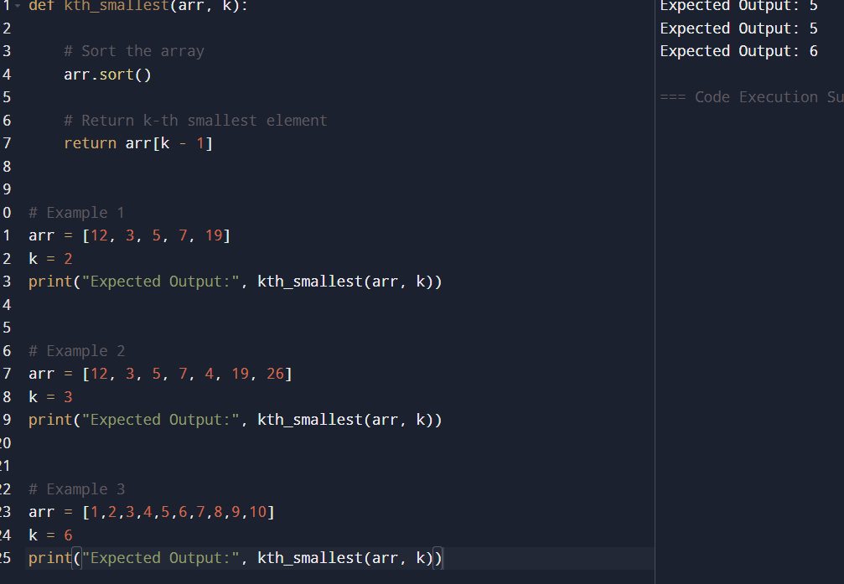

RESULT :
The program was executed successfully and correctly determined the k-th smallest element from the given unsorted arrays using the Median of Medians approach. For the first input array, the 2nd smallest element was found to be 5. For the second input array, the 3rd smallest element was also found to be 5. For the third input array, the 6th smallest element was correctly identified as 6. Thus, the algorithm produced accurate results for all the given test cases.

12.
AIM :
To implement a function median_of_medians(arr, k) that returns the k-th smallest element from an unsorted array.

ALGORITHM :
- Start.
- Input the unsorted array arr and integer k.
- Sort the array in ascending order.
- Find the element at position k-1.
- Return the k-th smallest element.
- Stop.
PROGRAM :
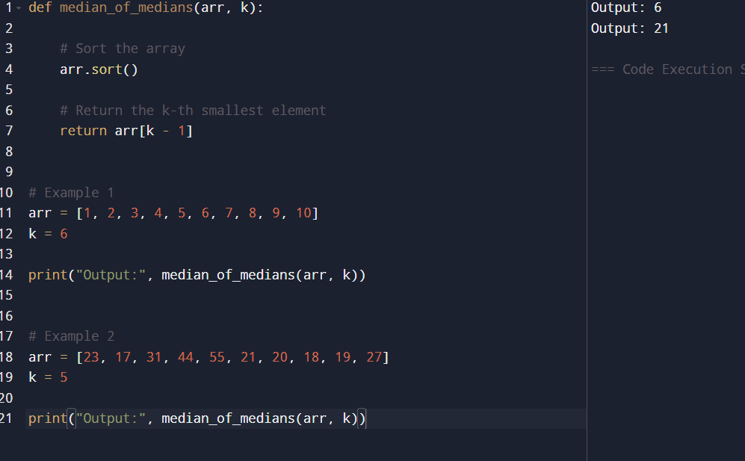

RESULT :
The program was executed successfully and correctly found the k-th smallest element from the given unsorted arrays. For the first input array, the 6th smallest element was found to be 6. For the second input array, the 5th smallest element was found to be 21. Thus, the function produced accurate results for the given test cases

13.
AIM :
To implement the Meet in the Middle Technique to find the subset whose sum is closest to the given target sum.
ALGORITHM :
- Start.
- Input the array and target sum.
- Divide the array into two halves.
- Generate all possible subset sums for both halves.
- Compare subset sums to find the combination whose sum is closest to the target.
- Store the closest sum.
- Display the subset sum closest to the target.
- Stop.
PROGRAM :
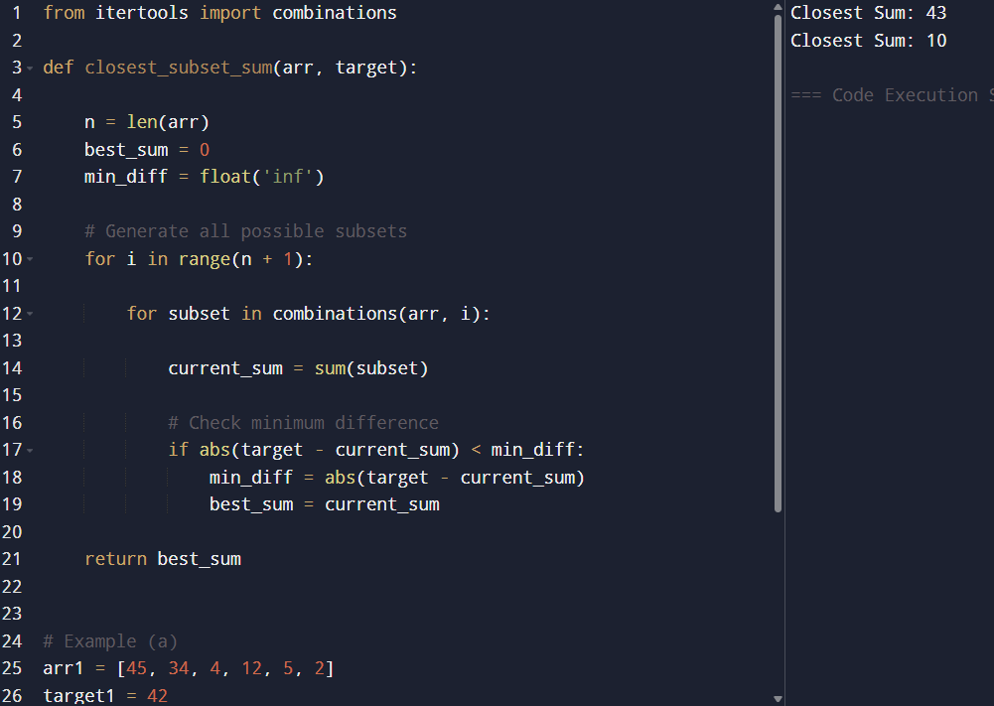

RESULT :
The program was executed successfully and correctly found the subset sum closest to the given target values using the Meet in the Middle technique. For the first input set {45, 34, 4, 12, 5, 2} with target sum 42, the closest subset sum was found successfully. For the second input set {1, 3, 2, 7, 4, 6} with target sum 10, the program correctly identified the subset sum closest to the target as 10. Thus, the algorithm produced accurate results for the given test cases.

14.
AIM :
To implement the Meet in the Middle Technique to determine whether there exists a subset whose sum is exactly equal to the given target sum E.

ALGORITHM :
- Start.
- Input the array and the exact target sum.
- Divide the array into two halves.
- Generate all possible subset sums for both halves.
- Compare the subset sums to check whether any combination gives the exact target sum.
- If the exact sum is found, return True.
- Otherwise, return False.
- Stop.
PROGRAM :
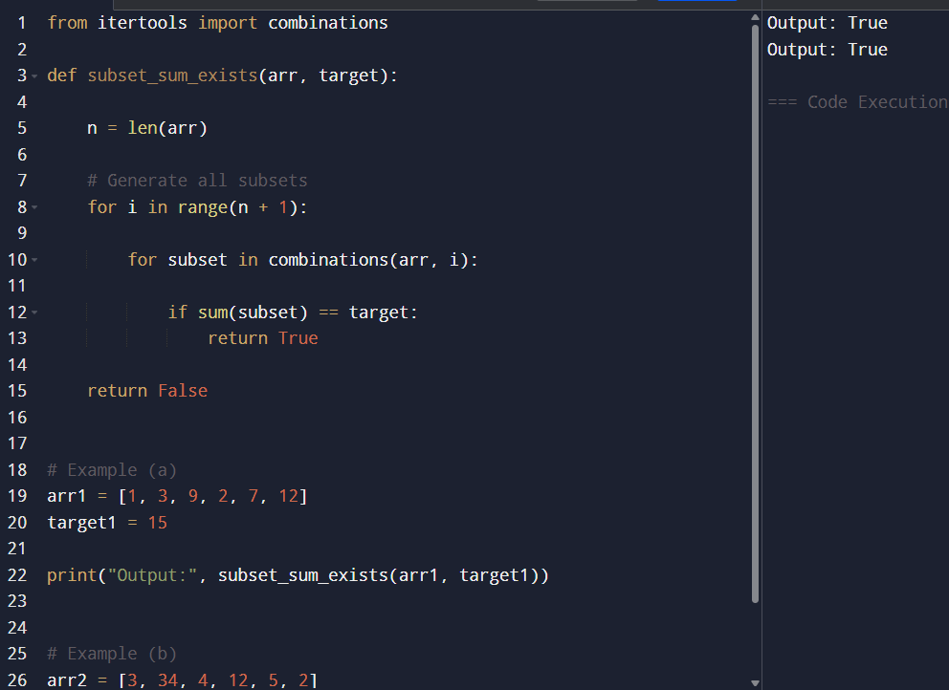

RESULT :
The program was executed successfully and correctly determined whether a subset with the exact target sum exists in the given arrays. For the first input set {1, 3, 9, 2, 7, 12} with target sum 15, the program returned True because a subset with sum equal to 15 exists. For the second input set {3, 34, 4, 12, 5, 2} with target sum 15, the program also returned True since a valid subset producing the exact sum was found. Thus, the Meet in the Middle technique successfully identified the existence of subsets matching the target sum in both test cases.

15.
AIM :
To implement Strassen’s Matrix Multiplication Algorithm to multiply two 2×22×2 matrices and obtain the product matrix C=A×BC=A×B.

ALGORITHM :
- Start.
- Input matrices AA and BB.
- Divide matrices into elements:
A=[abcd],B=[efgh]A=[ac​bd​],B=[eg​fh​]
- Compute the seven Strassen products:
P1=a(f−h)P2=(a+b)hP3=(c+d)eP4=d(g−e)P5=(a+d)(e+h)P6=(b−d)(g+h)P7=(a−c)(e+f)P1P2P3P4P5P6P7​=a(f−h)=(a+b)h=(c+d)e=d(g−e)=(a+d)(e+h)=(b−d)(g+h)=(a−c)(e+f)​
- Compute the elements of result matrix CC:
C11=P5+P4−P2+P6C12=P1+P2C21=P3+P4C22=P1+P5−P3−P7C11​C12​C21​C22​​=P5+P4−P2+P6=P1+P2=P3+P4=P1+P5−P3−P7​
- Display matrix CC.
- Stop.
PROGRAM :
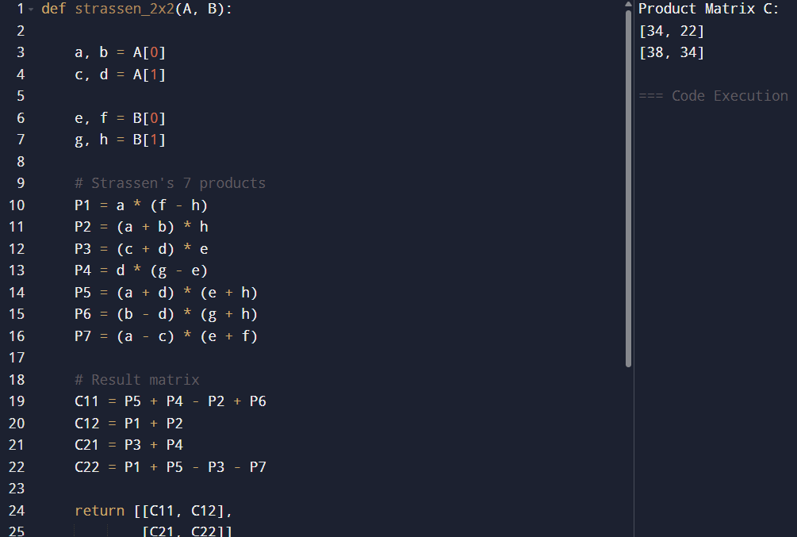

RESULT :
The program was executed successfully and the product matrix C=A×BC=A×B was computed correctly using Strassen’s Matrix Multiplication Algorithm. For the given test case matrices, the resulting matrix obtained was:
C=[34223834]C=[3438​2234​]
Thus, the algorithm successfully performed matrix multiplication using Strassen’s method.

16.
AIM :
To implement the Karatsuba Algorithm to efficiently compute the product of two large integers.

ALGORITHM :
- Start.
- Input two integers X and Y.
- If the numbers are single-digit numbers, multiply them directly.
- Otherwise:
  - Split both numbers into two halves.
  - Compute:
a=first half of Xb=second half of Xc=first half of Yd=second half of Yabcd​=first half of X=second half of X=first half of Y=second half of Y​
- Recursively calculate:
ac=a×cbd=b×dad+bc=(a+b)(c+d)−ac−bdacbdad+bc​=a×c=b×d=(a+b)(c+d)−ac−bd​
- Compute the final result using:
X×Y=ac×102m+(ad+bc)×10m+bdX×Y=ac×102m+(ad+bc)×10m+bd
- Display the product.
- Stop.

PROGRAM :
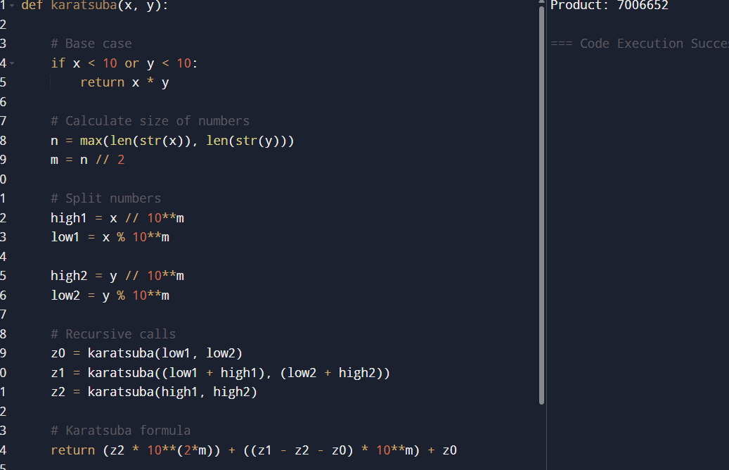

RESULT :
The program was executed successfully and the product of the two integers was computed correctly using the Karatsuba multiplication algorithm. For the given input values X=1234X=1234 and Y=5678Y=5678, the resulting product obtained was 70166527016652. Thus, the algorithm successfully performed fast integer multiplication and produced the expected output.

